
SRM Institute of Science and Technology
SET D
College of Engineering and Technology
School of Computing
SRM Nagar, Kattankulathur – 603203, Chengalpattu District, Tamilnadu
Academic Year: 2022-23 (EVEN)
Test: CLA-T2 Date: 29-03-2023
Course Code & Title: 18CSC204J Design and Analysis of Algorithms Duration: 1 hour 40 min
Year & Sem: II Year / IV Sem Max. Marks: 50

Course Articulation Matrix: (to be placed)
Course Outcome | PO1 | PO2 | PO3 | PO4 | PO5 | PO6 | PO7 | PO8 | PO9 | PO10 | PO11 | PO12
CO1 | 2 | 3 | - | - | - | - | - | - | - | - | - | -
CO2 | - | 3 | 2 | - | - | - | - | - | - | - | - | -
CO3 | - | 3 | 3 | - | - | - | - | - | - | - | - | -
CO4 | 3 | 2 | 3 | - | - | - | - | - | - | - | - | -
CO5 | 2 | 3 | - | - | - | - | - | - | - | - | - | -

Part - A
(10 x 1 = 10 Marks)
Instructions: Answer all
Q. No | Question | Marks | BL | CO | PO | PI Code
1 | The minimum number of worst-case iterations to be done in an array {45, 55, 65, 75, 85} to search an element 85 until the element is found.  - 2  - 3  - 4  - 5 | 1 | L1 | 2 | 2 | 2.5.2
2 | Select the number of comparisons required to find Min and Max using brute force and divide and conquer method.  - 2n-2 and 3(n/2)-2 comparisons  - 2n and n comparisons  - 2n and n-2 comparisons  - n(n-1) and 3n comparison | 1 | L1 | 2 | 2 | 2.5.2
3 | Pick the maximum subarray sum for {-1,3,4, -5,9}  - 13  - 17  - 1  - 11 | 1 | L2 | 2 | 2 | 2.6.3
4 | Apply Quick sort on a given sequence 8 12 15 7 10 5 4 13. What is the sequence after first phase, pivot is first element?  - 7 5 4 8 12 10 15 13  - 7 4 5 8 10 15 12 13  - 8 7 15 12 10 5 4 13  - 8 7 5 4 10 15 14 13 | 1 | L3 | 2 | 2 | 2.6.3
5 | Identify the true statement of convex hull  - Smallest convex polygon that does not contains all the points of S  - Smallest convex polygon that contains all the points of S  - Largest convex polygon that contains all the points of S  - Largest convex polygon that contains all the points of S | 1 | L1 | 2 | 2 | 2.5.2
6 | What is the time complexity of fractional knapsack problem in greedy approach?  - O (n log n)  - O(n)  - O (log n)  - O(log) | 1 | L1 | 3 | 2 | 2.5.2
7 | Which of the following design techniques guarantees optimal solution?  - Greedy  - Divide and Conquer  - Dynamic Programming  - Brute Force | 1 | L1 | 3 | 2 | 2.5.1
8 | If the number of keys in optimal binary search tree is 3. How many numbers of trees are possible?  - 2  - 3  - 4  - 5 | 1 | L1 | 3 | 2 | 2.6.3
9 | For a 6-node graph, how many number of edges is required to construct a minimum spanning tree?  - 6  - 5  - 7  - 12 | 1 | L2 | 3 | 2 | 2.5.2
10 | From the following given tree, what is the computed codeword for ‘A’?  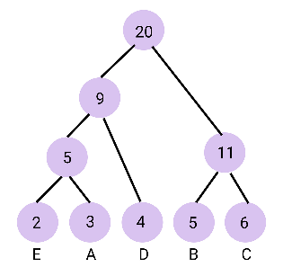  - 110  - 100  - 001  - 110 | 1 | L3 | 3 | 2 | 2.5.2
Part – B
(4 x 4 = 16 Marks)
Instructions: Answer Any FOUR Questions
16 | An array A contains N integers arranged in an arbitrary sequence. We want to check if all entries in A are distinct after sorting all the integers. Use an asymptotically efficient sorting algorithm using divide and conquer method and scan the sorted array from beginning to end looking for adjacent equal elements. Provide the pseudocode and mention its time complexity.  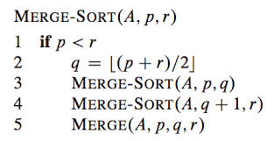  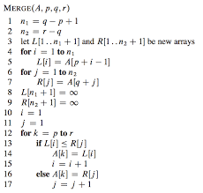  Time Complexity: O (n log n) | 4 | L3 | 3 | 3 | 3.6.2
17 | Apply divide and conquer method for the following scenario. Assume 20 face images are represented in grayscale values (pixel intensities). The number of intensity values (8-bit) used to represent each image is 70. For example, convex hull function requires 567 milliseconds to recognize the boundary of each face (divided part). Time taken to get conquered retinal boundary is 600 milliseconds /image. What is the total time taken to recognize the boundary of all faces?  To apply divide and conquer method for recognizing the boundary of all faces represented in grayscale values, we can divide the 20 images into smaller sub-problems of recognizing the boundary of each face using the convex hull function. We can then conquer the sub-problems by recognizing the boundary of each face using the convex hull function and adding the time taken to recognize the boundary of each face.  If 70 image points are divided in to two sets. Each set has 35 points.  For one image, 567+567=1134 milliseconds  For 20 images, 20*1134=22680 milliseconds (Division)  For conquering, One image, 600 milliseconds  For, 20 images, 12000 milliseconds  Total time to recognize the face section of the images, 22680+12000=34680 milliseconds=34.68 seconds | 4 | L3 | 3 | 2 | 2.6.3
18 | Apply a divide and conquer algorithm to perform A x B using 7 multiplications which has slightly better time complexity than O (n3)  A= 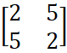 B = 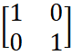  Strassen's algorithm is a divide-and-conquer approach to solve matrix multiplication efficiently. The standard matrix multiplication algorithm has a time complexity of O(n^3), which makes it inefficient for large matrices. Strassen's algorithm reduces the time complexity to O(n^log2(7)) ≈ O(n^2.81), making it more efficient than the standard algorithm for large matrices.  The algorithm works by recursively dividing the input matrices into smaller sub-matrices until a base case is reached, and then combining the sub-matrices using matrix additions and subtractions to obtain the final result. The base case is usually a matrix of size 1x1 or 2x2, where the matrix multiplication is performed directly.  The algorithm uses the following seven matrix operations to compute the product of two matrices A and B of size n x n:  Divide the matrices A and B into four sub-matrices of size n/2 x n/2 each.  Compute seven products of sub-matrices using matrix additions and subtractions:  a. P1 = A11 x (B12 - B22)  b. P2 = (A11 + A12) x B22  c. P3 = (A21 + A22) x B11  d. P4 = A22 x (B21 - B11)  e. P5 = (A11 + A22) x (B11 + B22)  f. P6 = (A12 - A22) x (B21 + B22)  g. P7 = (A11 - A21) x (B11 + B12)  Compute the resulting product matrix C by combining the seven products using matrix additions and subtractions:  a. C11 = P5 + P4 - P2 + P6  b. C12 = P1 + P2  c. C21 = P3 + P4  d. C22 = P5 + P1 - P3 - P7  Here, A11, A12, A21, A22, B11, B12, B21, and B22 are sub-matrices of A and B, respectively.  The algorithm has a space complexity of O(n^log2(7)), which is also more efficient than the standard algorithm. However, it has a higher constant factor and is not always faster than the standard algorithm for small matrices due to the overhead of the recursive calls and the additional arithmetic operations involved.  Overall, Strassen's algorithm is a useful approach for multiplying large matrices efficiently using divide-and-conquer techniques. | 4 | L3 | 3 | 2 | 2.6.3
19 | Suppose we have a weighted undirected graph with negative edge weights. Which method is suitable to compute Minimum Cost spanning Tree and provide the pseudocode for the same.  Both Prim’s and Kruskal’s can be used to compute MST.  Kruskal's algorithm falls under a class of algorithms called greedy algorithms that find the local optimum in the hopes of finding a global optimum.  We start from the edges with the lowest weight and keep adding edges until we reach our goal.  The steps for implementing Kruskal's algorithm are as follows:  - Sort all the edges from low weight to high  - Take the edge with the lowest weight and add it to the spanning tree. If adding the edge created a cycle, then reject this edge.  - Keep adding edges until we reach all vertices.  pseudocode for KRUSKAL(G):  A = ∅  For each vertex v ∈ G.V:  MAKE-SET(v)  For each edge (u, v) ∈ G.E ordered by increasing order by weight (u, v):  if FIND-SET(u) ≠ FIND-SET(v):  A = A ∪ {(u, v)}  UNION (u, v)  return A | 4 | L3 | 3 | 3 | 3.6.2
20 | Let's say the following characters need to be sent over a network. A character takes up 8 bits. The below characters contain a total of 7 characters. Hence, a total of 8 * 7 = 56 bits is required to deliver this string.  By using any compression method, how to reduce the string's size. Using the character's frequency information, constructs a tree before generating code for each character.  Huffman coding is a compression algorithm that generates variable-length codes for each character in a message based on their frequency of occurrence. Characters that occur more frequently are assigned shorter codes, while characters that occur less frequently are assigned longer codes.  To use Huffman coding for the given string, we can follow these steps:  Construct a binary tree with the given character frequencies using the following algorithm:  a. Create a leaf node for each character with its frequency as the weight.  b. Create a priority queue of all the leaf nodes, ordered by their weight.  c. While the priority queue has more than one node, do the following:  i. Take the two nodes with the smallest weight and create a new internal node with their sum as the weight.  ii. Make the two nodes’ children of the new internal node.  iii. Add the new internal node to the priority queue.  d. The root of the tree is the last remaining node in the priority queue.  Traverse the tree to generate the Huffman codes for each character. Starting from the root of the tree, assign a '0' to the left child and a '1' to the right child at each internal node. The Huffman code for a character is the sequence of '0's and '1's encountered while traversing from the root to its corresponding leaf node.  Using the character frequencies provided, here is the binary tree that can be constructed using the above algorithm:  55  / \  s(13) 42  / \  e(15) i(12)  / \  u(4) 21  / \  t(1) a(10)  \  o(3)  The Huffman codes for each character are:  s: 0  e: 10  i: 11  u: 1010  t: 1011  a: 110  o: 1110  Using the Huffman codes, we can represent the string "aeioustu" as the binary string "0001000011011101010111100111110", which has a length of 34 bits. This represents a compression of more than 39% compared to the original length of 56 bits. | 4 | L3 | 3 | 2 | 2.6.4
  Characters | a | e | i | o | u | s | t
  Frequencies | 10 | 15 | 12 | 3 | 4 | 13 | 1
Part – C
(2 x 12 = 24 Marks)
Instructions: Answer TWO Questions
21 | Your team manager asked you to write an application for your company to retrieve any record of an employee from the database that contains employee records sorted by their unique employee IDs. Also, she insists you use a search algorithm to quickly retrieve the medical records of a specific employee. Propose an algorithm with the time complexity analysis to meet your manager’s requirements for the given following sample data sets to get the approval from your manager.  i. Employee Records {202729, 202730, 202731, 202732, 202733, 202734, 202735, 202736, 202737, 202738}.  ii. Assume that the record of employee id 202738 needs to be retrieved for background verification to assign him in a new project.  Here is the algorithm to retrieve the medical records of a specific employee using binary search:  Example: (5 Marks)  Pseudocode: (6 Marks)  Time Complexity: (1 Mark)  Sort the employee records in ascending order of their unique employee IDs.  Set the lower bound to the first index of the array and the upper bound to the last index of the array.  While the lower bound is less than or equal to the upper bound, do the following:  a. Calculate the mid index as the average of the lower and upper bounds.  b. If the employee ID at the mid index is equal to the target employee ID, return the medical records of that employee.  c. If the employee ID at the mid index is less than the target employee ID, set the lower bound to mid + 1.  d. If the employee ID at the mid index is greater than the target employee ID, set the upper bound to mid - 1.  If the target employee ID is not found in the array, return an error message.  Using the given sample dataset, the algorithm to retrieve the medical records of employee id 202738 using binary search is as follows:  Sort the employee records in ascending order of their unique employee IDs: {202729, 202730, 202731, 202732, 202733, 202734, 202735, 202736, 202737, 202738}.  Set the lower bound to 0 and the upper bound to 9.  While the lower bound is less than or equal to the upper bound, do the following:  a. Calculate the mid index as the average of the lower and upper bounds: mid = (0 + 9) / 2 = 4.  b. If the employee ID at the mid index is equal to the target employee ID (202738), return the medical records of that employee.  c. If the employee ID at the mid index is less than the target employee ID, set the lower bound to mid + 1: lower = mid + 1 = 5.  d. If the employee ID at the mid index is greater than the target employee ID, set the upper bound to mid - 1: upper = mid - 1 = 3.  If the target employee ID is not found in the array, return an error message.  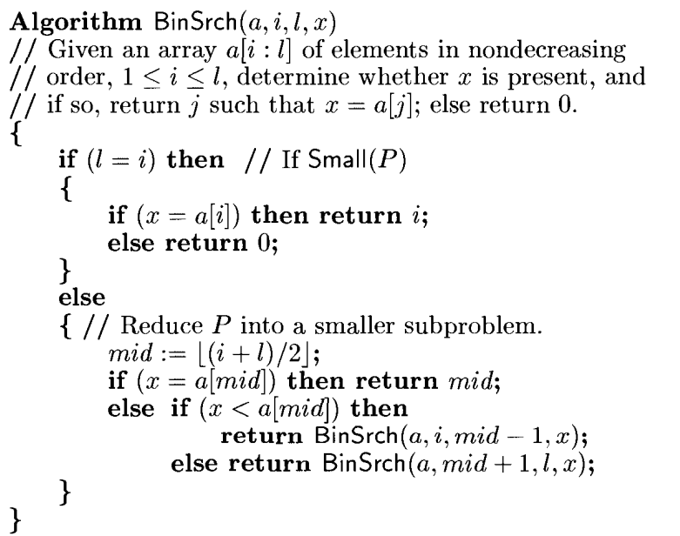  The time complexity of binary search algorithm is O (log n), where n is the number of elements in the sorted array. In the given sample dataset, the number of elements is 10, so the time complexity of binary search algorithm is O (log 10) = O(3), which is a constant time complexity. | 12 | L3 | 2 | 3 | 3.6.2
or |  |  |  |  |  |  |  | or
22 | Rishabh is working on a drone delivery system for a large city. The drones need to be able to navigate through the city while avoiding obstacles such as buildings and trees quickly and efficiently. Suggest an algorithm using divide and conquer method to determine whether the drones planned path intersects with any obstacles. Also provide the time complexity analysis. (Note: Your algorithm must be able to identify the tall buildings and trees)  Pseudocode: (8 Marks)  Time complexity analysis: (4 Marks)  - Sort all the points by their X coordinates. The tie is broken by ranking points according to their Y coordinate.  - Determine two extreme points A and B, where A represents the leftmost point and B represents the rightmost point. A and B would be the convex hull’s vertices. Lines AB and BA should be added to the solution set.  - Find the point C that is the farthest away from line AB.  - Calculate the convex hull of the points on the line AC’s right and left sides. Remove line AB from the original solution set and replace it with AC and CB.  - Process the points on the right side of line BA in the same way.  - Find the convex hull of the points on the left and right of the line connecting the two farthest points of that specific convex hull recursively.  Algorithm ConvexHull(P)  // P is a set of input points  Sort all the points in P and find two extreme points A and B  S1 ← Set of points right to the line AB  S2 ← Set of points right to the line BA  Solution ← AB followed by BA  Call FindHull(S1, A, B)  Call FindHull(S2, B, A)  Algorithm for subroutine FindHull is described below :  Algorithm FindHull(P, A, B)  if isEmpty(P) then  return  else  C ← Orthogonally farthest point from AB  Solution ← Replace AB by AC followed by CB  Partition P – { C } in X0, X1 and X2  Discard X0 in side triangle  Call FindHull(X1, A, C)  Call FindHull(X2, C, B)  end  T(n) = 2T(n/2) + O(n)  T(n) = O(n.log₂n) | 12 | L3 | 2 | 3 | 3.6.2
23 | A burglar enters a home to commit a robbery. The most weight he can fit in his bag is 60 kg. The following weights and values apply to the following 4 items in the home. Which items, if any, should a thief take with him if he can even take a portion of any item? Write the pseudocode and its time complexity.  sing the Greedy method or the Fractional Knapsack algorithm, where we sort the items in non-increasing order of value/weight ratio and pick items as much as we can. Here is the pseudocode for the Fractional Knapsack algorithm:  Pseudocode: (5 Marks)  Example: (5 Marks)  Time complexity: (2 Marks)  Sort the items in non-increasing order of value/weight ratio.  Initialize the total value of the items taken to zero and the remaining capacity of the bag to W.  For each item i from 1 to n, do the following:  a. If the weight of the item i is less than or equal to the remaining capacity of the bag, take the whole item and add its value to the total value of the items taken.  b. If the weight of the item i is greater than the remaining capacity of the bag, take a fraction of the item that fills the remaining capacity of the bag and add its value to the total value of the items taken.  c. If the bag is full, terminate the loop and return the total value of the items taken.  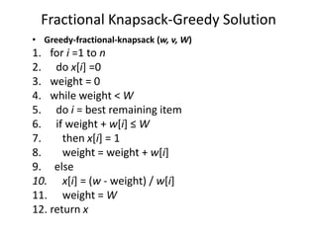  Using the given sample data, we can calculate the value/weight ratio for each item:  yaml  Copy code  Item 1: 90/25 = 3.6  Item 2: 45/15 = 3.0  Item 3: 40/10 = 4.0  Item 4: 77/22 = 3.5  Item 5: 30/5 = 6.0  Then, we sort the items in non-increasing order of value/weight ratio:  yaml  Copy code  Item 5: 30/5 = 6.0  Item 3: 40/10 = 4.0  Item 4: 77/22 = 3.5  Item 1: 90/25 = 3.6  Item 2: 45/15 = 3.0  Using the remaining capacity of the bag, we take as much of the items as we can:  yaml  Copy code  Bag Capacity: 60 kg  Take Item 5: 5 kg, Total Value: 30  Take Item 3: 10 kg, Total Value: 70  Take Item 4: 22 kg, Total Value: 203  Take 23 kg of Item 1: Total Value: 623  The total value of the items taken is 623. Therefore, the burglar should take a portion of Item 1, Item 3, Item 4, and the whole Item 5. The time complexity of the Fractional Knapsack algorithm is O(n log n) due to the sorting step. | 12 | L3 | 3 | 3 | 3.6.2
  Items | 1 | 2 | 3 | 4 | 5
  Weight | 25 | 15 | 10 | 22 | 5
  Value | 90 | 45 | 40 | 77 | 30
or |  |  |  |  |  |  |  | or
24 | Demonstrate Multiplication of a sequence of n matrices A₁, A₂…. A_{n}. Find the optimal parenthesizing of n matrices that have minimal number of multiplications using dynamic programming with an example where n=5 defined by, ixj, jxk, kxl, lxm and mxn  i=2, j=i+1, k= j-1, L= k+2, m= L-1, n= m-1  The problem of finding the optimal parenthesizing of n matrices that have minimal number of multiplications can be solved using dynamic programming. We can define a table of size n x n to store the minimum number of multiplications required to compute the product of the matrices. The entry in the i-th row and j-th column represents the minimum number of multiplications required to compute the product of matrices Ai, Ai+1, ..., Aj.  Pseudocode: (4 Marks)  Example: (7 Marks)  Time complexity: (1 Mark)  Here is the pseudocode for the dynamic programming approach:  css  Copy code  MatrixChainOrder(p)  1. n = p.length - 1  2. Let m[1..n, 1..n] and s[1..n-1, 2..n] be tables  3. For i = 1 to n  4. m[i,i] = 0  5. For L = 2 to n // L is the chain length  6. For i = 1 to n - L + 1  7. j = i + L - 1  8. m[i,j] = infinity  9. For k = i to j - 1  10. q = m[i,k] + m[k+1,j] + p[i-1] * p[k] * p[j]  11. If q < m[i,j]  12. m[i,j] = q  13. s[i,j] = k  14. Return m and s  Here, p is an array of matrix dimensions, where the i-th matrix has dimensions p[i-1] x p[i]. The algorithm returns two tables: m and s. The table m stores the minimum number of multiplications required to compute the product of matrices, and the table s stores the optimal parenthesizing of matrices.  Using the given matrix dimensions, we can define the array p as follows:  css  Copy code  p = [2, 3, 4, 5, 6]  The dimensions of the matrices are as follows:  makefile  Copy code  A1: 2 x 3  A2: 3 x 4  A3: 4 x 5  A4: 5 x 6  We can apply the MatrixChainOrder function to find the optimal parenthesizing of matrices and the minimum number of multiplications required:  scss  Copy code  m, s = MatrixChainOrder(p)  m = [ [0, 24, 54, 108, 174],  [0, 0, 60, 132, 228],  [0, 0, 0, 120, 270],  [0, 0, 0, 0, 180],  ]  s = [ [0, 1, 1, 3],  [0, 0, 2, 3],  [0, 0, 0, 3],  [0, 0, 0, 0],  ]  The minimum number of multiplications required to compute the product of matrices is 174, and the optimal parenthesizing is ((A1A2)((A3A4)A5)). This means that we first compute the product of A1 and A2, then compute the product of A3 and A4, and finally compute the product of the result of the first computation and A5. The time complexity of the algorithm is O(n^3), where n is the number of matrices. | 12 | L3 | 3 | 3 | 3.6.2

*Program Indicators are available separately for Computer Science and Engineering in AICTE examination reforms policy.

Course Outcome (CO) and Bloom’s level (BL) Coverage in Questions

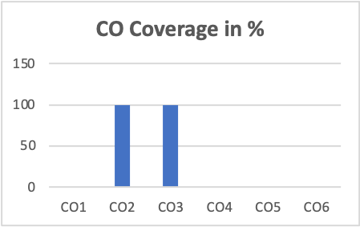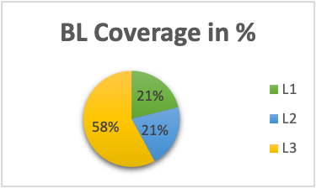

Approved by the Audit Professor/Course Coordinator

